Name: **Varoon Kumar**

Roll No: **25k-0617**

PF lab 05

Question 01

**Code:**

#include <stdio.h>

#include <ctype.h>

int main() {

char inputChar;

int vowelCount = 0, consonantCount = 0;

printf("Enter 3 characters one by one:\n");

for (int idx = 0; idx < 3; idx++) {

printf("Character %d: ", idx + 1);

scanf(" %c", &inputChar);

inputChar = tolower(inputChar);

if (inputChar >= 'a' && inputChar <= 'z') {

if (inputChar == 'a' || inputChar == 'e' || inputChar == 'i' || inputChar == 'o' || inputChar == 'u') {

vowelCount++;

} else {

consonantCount++;

}

} else {

printf("'%c' is not an alphabet character.\n", inputChar);

}

}

printf("Total vowels: %d\n", vowelCount);

printf("Total consonants: %d\n", consonantCount);

return 0;

}

Output:

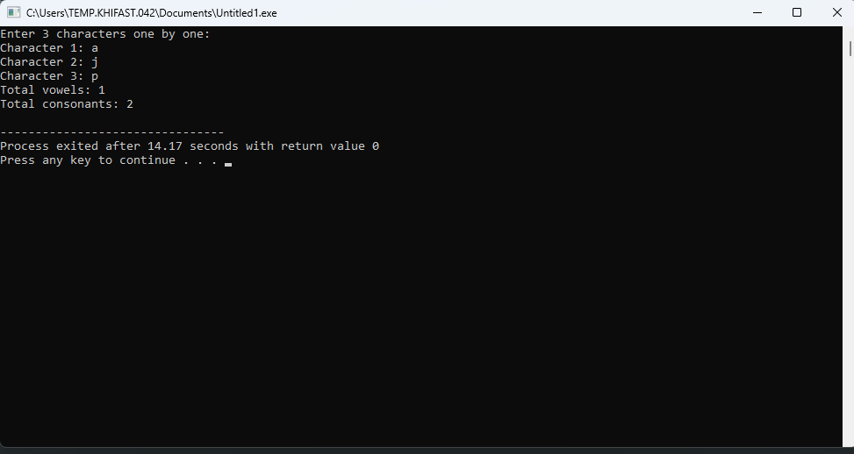

Question 02

**Code:**

#include <stdio.h>

int main() {

int num;

// Input the number

printf("Enter an integer: ");

scanf("%d", &num);

// Nested ternary operator for classification

(num % 2 == 0) ? printf("Even\n") : ((num % 3 == 0) ? printf("Divisible by 3\n") : printf("Odd and not divisible by 3\n"));

return 0;

}

**Output:**

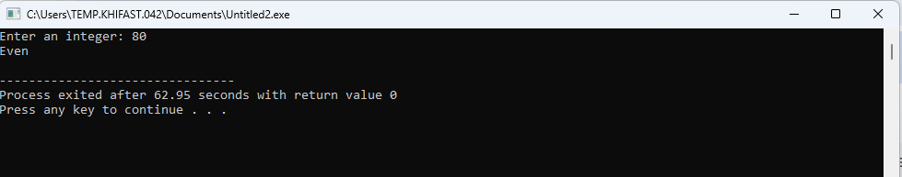

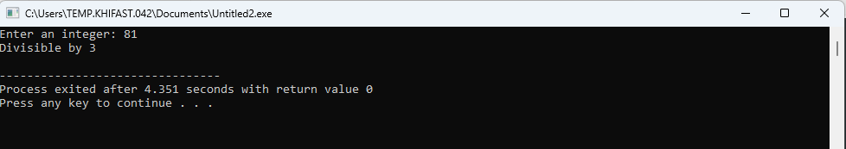

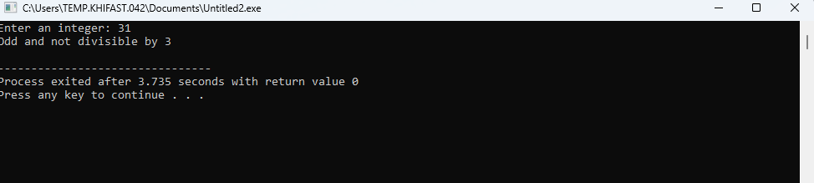

Question 05

**Code:**

#include <stdio.h>

int main() {

int mark1, mark2, mark3, largest;

// Input marks

printf("Enter marks of three students:\n");

scanf("%d %d %d", &mark1, &mark2, &mark3);

// Nested ternary to find the largest

largest = (mark1 > mark2) ?

((mark1 > mark3) ? mark1 : mark3)

:

((mark2 > mark3) ? mark2 : mark3);

printf("The largest mark is: %d\n", largest);

return 0;

}

Output:

